**Guidance – remove this box before submitting!**

Yellow callout boxes provide general notes. Please remove the yellow boxes before submitting. For full guidance see <https://peerj.com/about/author-instructions>

Blue highlighted example text should be replaced or removed with your own information.

|  |  |
| --- | --- |
| **DO**  –Use clear and grammatically correct English.  –Save as US Letter size format.  –Ensure line numbering is enabled.  –Align text LEFT.  –Ensure title, abstract, and author information matches what is entered online during submission. | **DO NOT**  –Embed ANY figures or tables in the text. Instead, upload a separate file for each on the file uploads page when submitting. Example – If you have 3 figures, then you will upload 3 figure files & be asked to add a figure title for each. See <https://peerj.com/about/author-instructions/#figures> for figure formats. |

**A new high throughput assay for measuring zebrafish anxiety: tall tanks that generate more between-individual variation**

FirstName MiddleName LastName1, FirstName MiddleName LastName2, FirstName MiddleName LastName3, FirstName MiddleName LastName4, FirstName MiddleName LastName1

1 Department Name, Institution Name, City, State/Province, Country

2 Department Name, Institution Name, City, State/Province, Country

3 Department Name, Institution Name, City, State/Province, Country

4 Department Name, Institution Name, City, State/Province, Country

Corresponding Author:

FirstName LastName1

Street Address, City, State/Province, Zip code, Country

Email address: corresponding_author_email@email.com

**Abstract**

Add your abstract here.

**Abstract Guidance – remove this box before submitting!**

* No more than approx. 500 words (or 3,000 characters).
* Self-contained and concisely describe the reason for the work, methodology, results, and conclusions. Uncommon abbreviations should be spelled out at first use. Do not include footnotes or references.
* Headings in structured abstracts should be bold and followed by a period. Each heading should begin a new paragraph. For example:

**Background.** The background section text goes here. Next line for new section.

**Methods.** Methods section here, then new line.

**Results.** Results section here, then new line.

**Discussion.** Discussion section here.

**Introduction outline**

1. Start more general – inferring internal states of animals from behaviour has been important and a challenge. Also, here introduce how people measure anxiety (not just the novel tank dive test) and how important it is for animal research, which inform human health etc.
2. A lot of behaviour assays are there but the issue of repeatably of these assays have been long neglected. And you introduce something about repeatability (importance of repeatability in the context of animal behaviour)
3. Sex differences ?

- Zebrafish anxiety an important assay in many fields (behaviour, medicine)

- Novel tank test common assay used to test zebrafish anxiety (sentence to describe logic behind assay)

- Typically, studies use short tanks, describe briefly why this is inadequate (height, variation); also mention how we conducted a systematic survey.

4 – the aim of this work

**Introduction**

Behavioral assays are developed and act as important indicators of physiological or psychological state (Brown and Bolivar 2018). One such state is anxiety. Anxiety is characterized by excessive worry, hyperarousal and debilitating fear and is worryingly prevalent worldwide in many population subgroups (Remes et al. 2016). In addition, anxiety is associated with a range of other health issues (Culpepper 2009) and places heavy economic burden on affected individuals (Konnopka and König 2020). Consequently, the importance of anxiety research using animal models has increased greatly over the last several decades (Harro 2018).

Zebrafish have emerged as a popular animal model to measure anxiety. They possess a complex behavioral repertoire (Cachat et al. 2011) and display behavioral phenotypes which can be quantified to measure an anxiety state (Stewart et al. 2012). In addition, they are inexpensive to maintain and they reproduce readily, allowing for high-throughput screening and heavy experimental manipulation (Nguyen et al. 2013).

A common method used to measure Zebrafish anxiety is the novel tank diving test. This method exploits the Zebrafish’s natural tendency to seek shelter in unfamiliar environments by diving, freezing, and reducing exploration. Researchers assess anxiety by collecting data on behavioural parameters such as time spent at the bottom, latency to enter the upper half of the tank, total distance travelled, and freezing (Egan et al. 2009).

While these tests are heavily employed, there is little to no research on using tanks that differ in depth to typical holding tanks. This is crucial, as zebrafish have been shown to prefer greater surface depth (Blaser and Goldsteinholm 2012). As such, we believe utilizing tanks with increased depth will result in more variation in behavioural responses among individuals, and more reliable estimates of repeatability. Repeatability is an important index used to quantify measurement accuracy and the constancy of phenotypes. Repeatability, also known as intra-class correlation (ICC) is the proportion of phenotypic variation that can be attributed to between-subject (or between-individual) variation (Nakagawa and Schielzeth 2010). A behavioural assay with low repeatability would be less useful and reliable because low repeatability indicates no consistent individual changes in behaviour.

Aims…

**Guidance – remove this box before submitting!**

DO NOT embed figures or tables in any section of the text. You will upload as individual files during submission. DO however cite the figures and tables in your text. They MUST be organized, and cited for the first time, in ascending numerical order. This means that Figure 1 must be the first figure in the text and be cited first, etc. See [figure instructions](https://peerj.com/about/author-instructions/#figures) and [table instructions](https://peerj.com/about/author-instructions/#table-files).

**Materials & Methods**

**1. Systematic survey**

* Detail methodology of systematic search (i.e. database used, keywords used, dates)
* Inclusion criteria
* Data extraction and coding

**2. Empirical part**

**Zebrafish husbandry**

* Paragraph for this is already written, need to mention sample sizes
* Ethics statement and permit number

**Tank types**

* Describe tanks that are being used (dimensions, standardization; refer to figures)

**Experimental design**

* Detail experimental design to describe how we will test repeatability in both short and tall tanks (can refer to protocol)
* Describe pseudorandomization process to account for things like time of day, order of tanks being run etc.
* Extraction via Ethovision (can refer to protocol)

**Statistical analysis**

* See Takuji’s paper for a good guideline regarding the repeatability analysis
* Mention which packages were used for analysis (rptr) and what factors were used as fixed and what were used as random (also mention how data was subset into tall and short and also analyzed when both were together); “Uncertainty in repeatability estimates was obtained using parametric bootstrapping, which was set to 10,000 for all models”
* Detail how differences were calculated between short and tall tank repeatabilities; and between males and females in tall and males and females in short tank**s**

**Materials and methods**

*Systematic review/Anxiety survey*

Using a pre-defined search string, we performed a systematic review/survey of the academic literature using the online database Scopus in May 2020. We screened titles and abstracts of downloaded bibliometric records using Rayyan QCRI (Ouzzani et al. 2016). We aimed to identify experimental studies using laboratory zebrafish in novel tank test anxiety assays. From 50 included studies, we coded experiment-level information such as study focus (i.e. behavioural, medical), treatment (i.e. drugs) and tank type (i.e. rectangular, trapezoidal). We extracted numbers pertaining to tank capacity, tank dimensions, duration of assay and sample sizes and coded zebrafish behavioural endpoints (see Supplemental Materials for full list) used to assess an anxiety state. Following extraction, we tallied behavioural endpoints to select the most commonly used and include in our study.

*Zebrafish husbandry*

Mixed Wildtype (WT) zebrafish stock was raised and maintained in a Tecniplast Zebtec System at 28°C under a 12-h light:12-h dark cycle at the Garvan Institute of Medical Research, Sydney, Australia. Adult zebrafish were housed in 3.5L tanks (max 24 fish per tank), and larval zebrafish until 1 month of age were housed in 1.1L tanks (max 40 fish per tank). At 60dpf, we marked zebrafish with Visible Implant Elastomer tags (VIE, Northwest Marine Technologies, Inc.; Shaw Island, Washington, United States) for individual identification. We used a total of 160 WT zebrafish (n=79 males, n=81 females). All tanks received recirculating water (pH 7-8, conductivity 500-2500 μs). Zebrafish were fed a standard facility diet of Paramecium twice daily, up until 10-12 dpf, at which point they were weaned onto live Artemia (twice a day) and dried fish food (once a day). All animal experiments were approved by the Garvan Animal Ethics Committee (approval: ARA 18_18), with handling and maintenance following established protocols.

*Testing apparatus*

We employed the use of two different tanks (see Figure 1): 1 non-novel holding tank typically used in zebrafish anxiety assays (trapezoidal; at top widest point width 11cm, height 17.5cm, length at top widest point 28cm) and 1 novel tall tank with custom dimensions to increase depth (width 7cm, height 152cm, length 10.5cm). Each had a standardized mark displaying the water level at 3.4L.

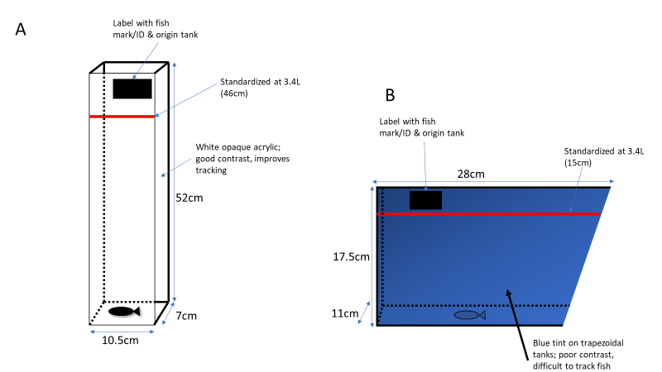

*Figure 1) Tanks used in our anxiety experiments; A) Novel tall tank composed of white opaque acrylic and B) traditional trapezoidal holding tank used to house zebrafish. Blue tinted tank ! Add information in there! Water was marked at 3.4L and standardized by the red line…Red marks were used to mark water level, with labels placed above indicating fish mark/ID and origin tank*

*Experimental setup*

When using our tall tanks, we set up 6 tanks to run 6 fish per trial. All 6 tanks were set up side by side and facing the camera (Figure 2A). Corflute was used to block all sides of the arenas except the front portion where the camera was placed; this ensures that fish are not disturbed during trials. When utilizing our trapezoidal tanks, we set up 8 tanks to run 8 fish per trial. The setup for the trapezoidal tanks required the use of 2 cameras (4 tanks per camera). In order to fit 4 tanks in the frame of one camera, we placed a platform (raised approximately 25cm) behind two tanks to place an additional two tanks on top (Figure 2B). Corflute was also placed in between the tanks (to prevent fish from seeing each other) and behind (to improve contrast). This same setup was used on the other half of the main platform (corflute was placed between both setups). Tanks were labeled appropriately with individual fish mark, and tank ID.

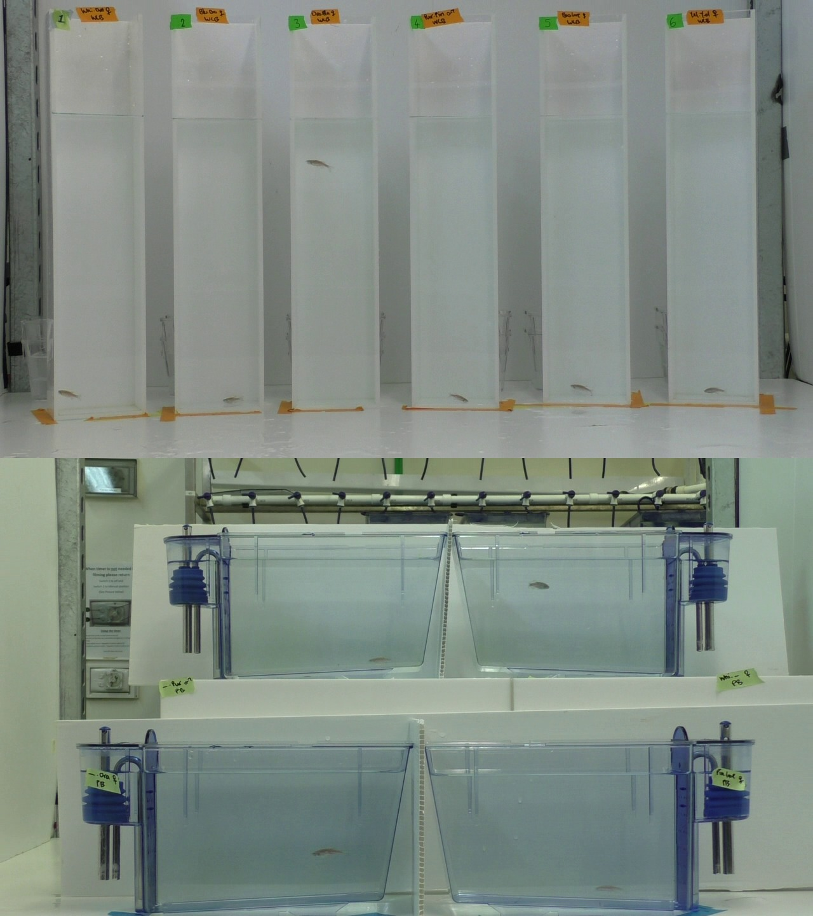

*Figure 2)*

*Experimental design and procedure*

Each individual experienced the anxiety assay in each tank twice. For each experiment, all fish were run in a single day. Order of tanks run were pseudorandomized to account for day of experiments as well as time of day. Individuals were then selected randomly to run in trials. Fish were placed in testing tanks and recorded for eight minutes. Acquisition of data began after 40 seconds. Trials began at 10am and ended at 4pm, with water changes occurring every hour to account for drops in temperature and addition of stress hormones from fish already trialled.

*Behavioural* *and statistical* *analyses*

All videos were analyzed with the video tracking software Ethovision XT 14.0 (Noldus, Spink and Tegelenbosch, 2001), which was also used to create three digital zones (lower, middle and upper third) in the tanks for analysis (see Ethovision protocol in Supplementary Materials). We assessed anxiety by analyzing commonly reported behaviours in zebrafish anxiety studies as identified in our anxiety survey: time spent in the lower third, middle third and upper third of the tank; latency to enter the upper third of the tank as well as number of entries into the upper third; total distance travelled; and time spent freezing (Stewart *et al.*, 2012).

Statistical analysis was done in R Studio (Version 1.1.453). Normality of anxiety behavioural endpoints and constant variance of residuals was checked prior to analyses by generating mixed models with the R package *lme4* (version 20) (Bates et al. 2014). We used tank type and sex as fixed factors, and fish ID as a random factor. We applied transformations to the following endpoints to meet normality assumptions: time spent in the upper third and entries into the upper third (square root); and time spent freezing (natural logarithm). Using the *rptr* package (Version 0.9.21) (Stoffel, Nakagawa, and Schielzeth 2017), we calculated repeatability estimates based on a mixed-effects model framework with *lme4*. Repeatability (R) is formally defined as the proportion of among-group variance out of total variance (Sokal and Rohlf 2012):

where is the between-group variance and is the within-group variance. We performed four sets of analyses. First, we subsetted our overall dataset by tank type (i.e. short and tall) and obtained repeatability estimates of anxiety behavioral endpoints in both tall and short tanks. Second, we further subsetted our dataset by sex and obtained repeatability estimates of males and females in both tall and short tanks. All estimates were unadjusted and only included individual fish ID’s as a random effect. Using *rptr* we obtained standard error and 95% confidence intervals (CI’s) using parametric bootstrapping (Faraway 2016) with all models set to 10,000. Third, we calculated contrasts between repeatability estimates. This was achieved by calculating differences between estimated bootstrap distributions and obtaining quantiles at 2.5% and 97.5% from this difference. Contrasts were deemed significant if the difference distribution did not fall below the 2.5% threshold. We calculated differences between tall and short tanks in our overall analysis, and between males and females in each tank type. Lastly, we compared variance estimates between tank types. We achieved this by creating two mixed models per endpoint: one with a constant variance structure for tank types using *varIdent* from the *nlme* package (version 3.1-148) (Pinheiro et al. 2020); and one without. An analysis of variance was then performed on both models to find differences in variance (cutoff for significance was 0.05).

**Materials & Methods Guidance – remove this box before submitting!**

* Methods should be described with sufficient detail & information to replicate.
* Review the [raw data and materials sharing policies](https://peerj.com/about/policies-and-procedures/#data-materials-sharing).
* Where IRB approval was required, you MUST provide an ethics statement as part of their Materials & Methods section detailing full information regarding their approval (including the name of the granting organization, and the approval reference numbers).​​ If an approval reference number is not provided, written approval must be uploaded on the files upload page as confidential supplemental file.
* If describing a new species then you MUST include specific text in the materials & methods. See [New species policies](https://peerj.com/about/policies-and-procedures/#new-species).

**Results**

**1. Systematic survey**

**Results Guidance – remove this box before submitting!**

All statistical results should be fully reported, including the test that was performed, the corresponding test statistic, degrees of freedom, the exact p-value (not, e.g. "p<0.05"), and effect sizes. For uploaded statistical figures, where appropriate, we recommend that you overlay bar graphs with scatter plots showing individual data points, or use another method to show the distribution of the data, such as boxplots, violin plots, etc.

**Cropped gel photos**

If you have primary cropped gel pictures then you MUST also upload the full-length **uncropped** pictures as a supplemental file (compressed as a single ZIP file if more than one). If the ZIP file is >30MB then upload to FigShare and provide the link to staff in the declarations section during submission.

* Detail the results of the survey with descriptive writing (refer to figures)
* Highlight the parameters we chose to analyze in the experiment, based on survey

**2. Empirical study**

**Behavioral measurements and difference**

**Repeatability analysis (overall)**

* Summarize main findings of repeatability analysis (refer to figures)

**Repeatability analysis (by sex)**

* Summarize main findings (refer to figures?)
* **Discussion**
* First paragraph to sum our main findings which we can discuss in detail in subsequent paragraphs

**1. Systematic survey**

* There’s a pattern of main parameters that are used and these reflect zebrafish behaviour to dive, explore etc.
* Discuss the fact that there is a trend using short tanks, not much variation in the types of tanks used; the methods aren’t very efficient considering only one fish can be measured at a time

**2. Empirical study**

**Repeatability overall**

* Re-highlight the importance of repeatability; discuss implications of results (are tall tanks better? What does this mean in biological context?)

**Sex differences in repeatability**

* Discuss why sex effects are important (there will always be differences between males and females and this must be taken into account in future studies)

**Limitations and future directions**

* Address limitations associated with using trapezoidal tanks; only 2 repeats
* could be tested on other zebrafish populations and strains

**Discussion Guidance – remove this box before submitting!**

* Start with the most important findings first.
* Link your results to any previous studies and how they add value and/or why results differ from what was previously demonstrated.
* What are the strengths and weaknesses/limitations and/or unexpected outcomes of the study results? Any inconclusive results?

**Conclusions**

* Mention animal personality briefy and rehighlight the importance of anxiety assays and the innovative and game-changing ideas behind the use of our tall tanks (high throughput, better contrast, allows larger sample size; SELL AND FINISH WITH A BANG)

**Conclusions Guidance – remove this box before submitting!**

* Concisely restate the hypothesis and most important findings.
* Summarize the major findings, contributions to existing knowledge, and limitations.
* What are the future directions?
* Speculation is welcome, but should be identified as such.
* Conclusions MUST be well stated, linked to original research question & limited to supporting results.

**Acknowledgements**

Add your acknowledgements here.

**Acknowledgements Guidance – remove this box before submitting!**

* Should not be used to acknowledge funders – funding will be entered online in the declarations page as a separate Funding Statement and appear on the published paper.
* As a matter of courtesy, we suggest you inform anyone whom you acknowledge.

**References**

Add your references here.

**Figures and tables**

* We need figures to visualize the following: Tank types, experimental setup, results of systematic search, repeatability results for overall analysis and sex analysis, violin plots to display raw data of parameters analyzed (with sex differences, error)
* We need a table to summarize repeatability results of both overall analysis and sex analysis; as well as summaries of parameter results
* TABLE 1) SUMMARY OF REPEATABILITY RESULTS FOR BOTH OVERALL AND SEX ANALYSIS
* TABLE 2) SUMMARY OF PARAMETER RESULTS

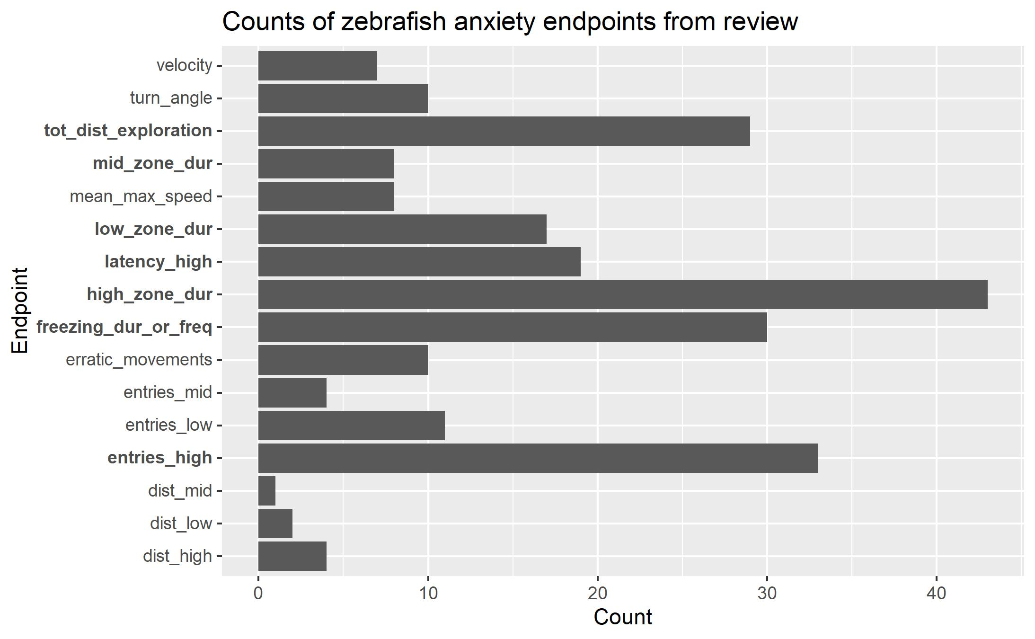

Figure 4)

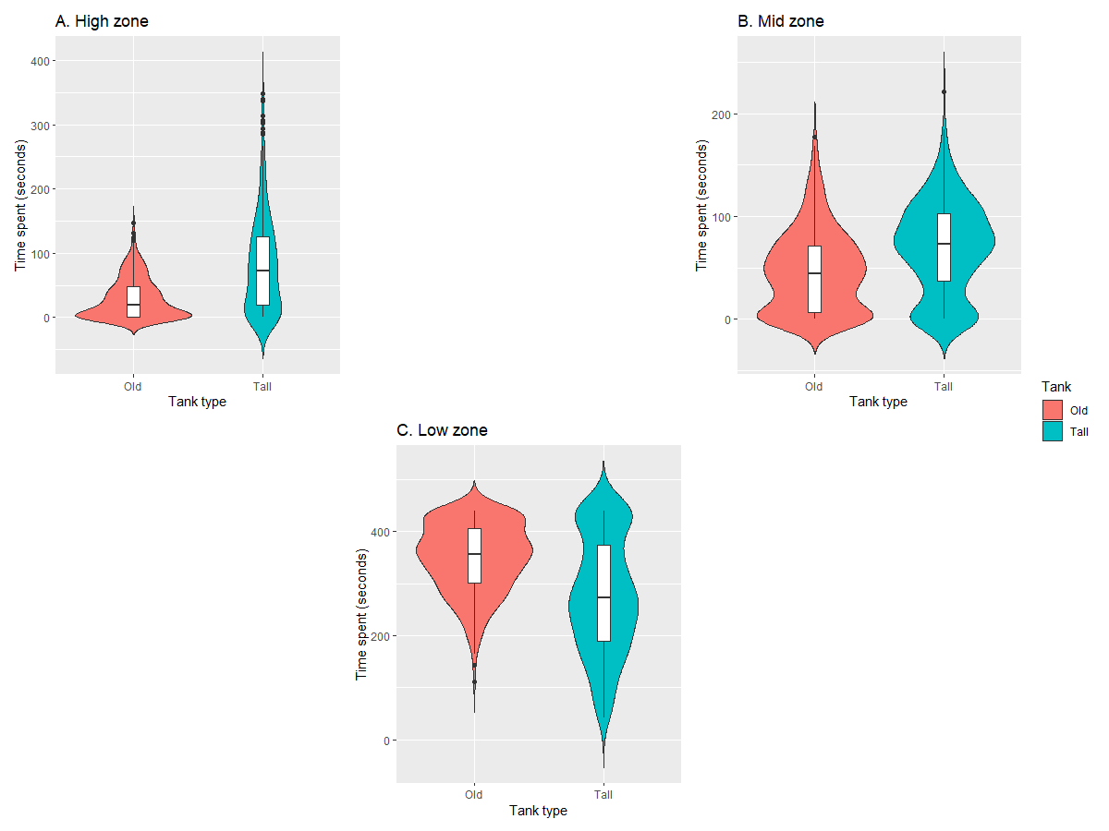

Figure 5)

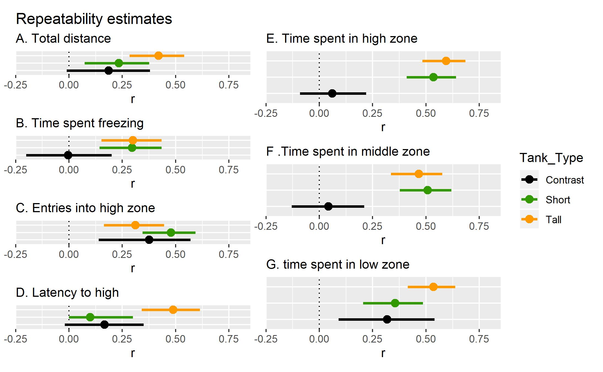

OR

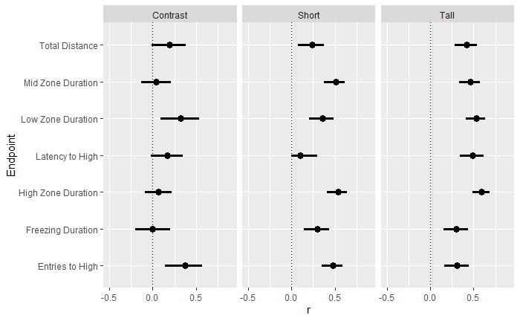

Figure 6)

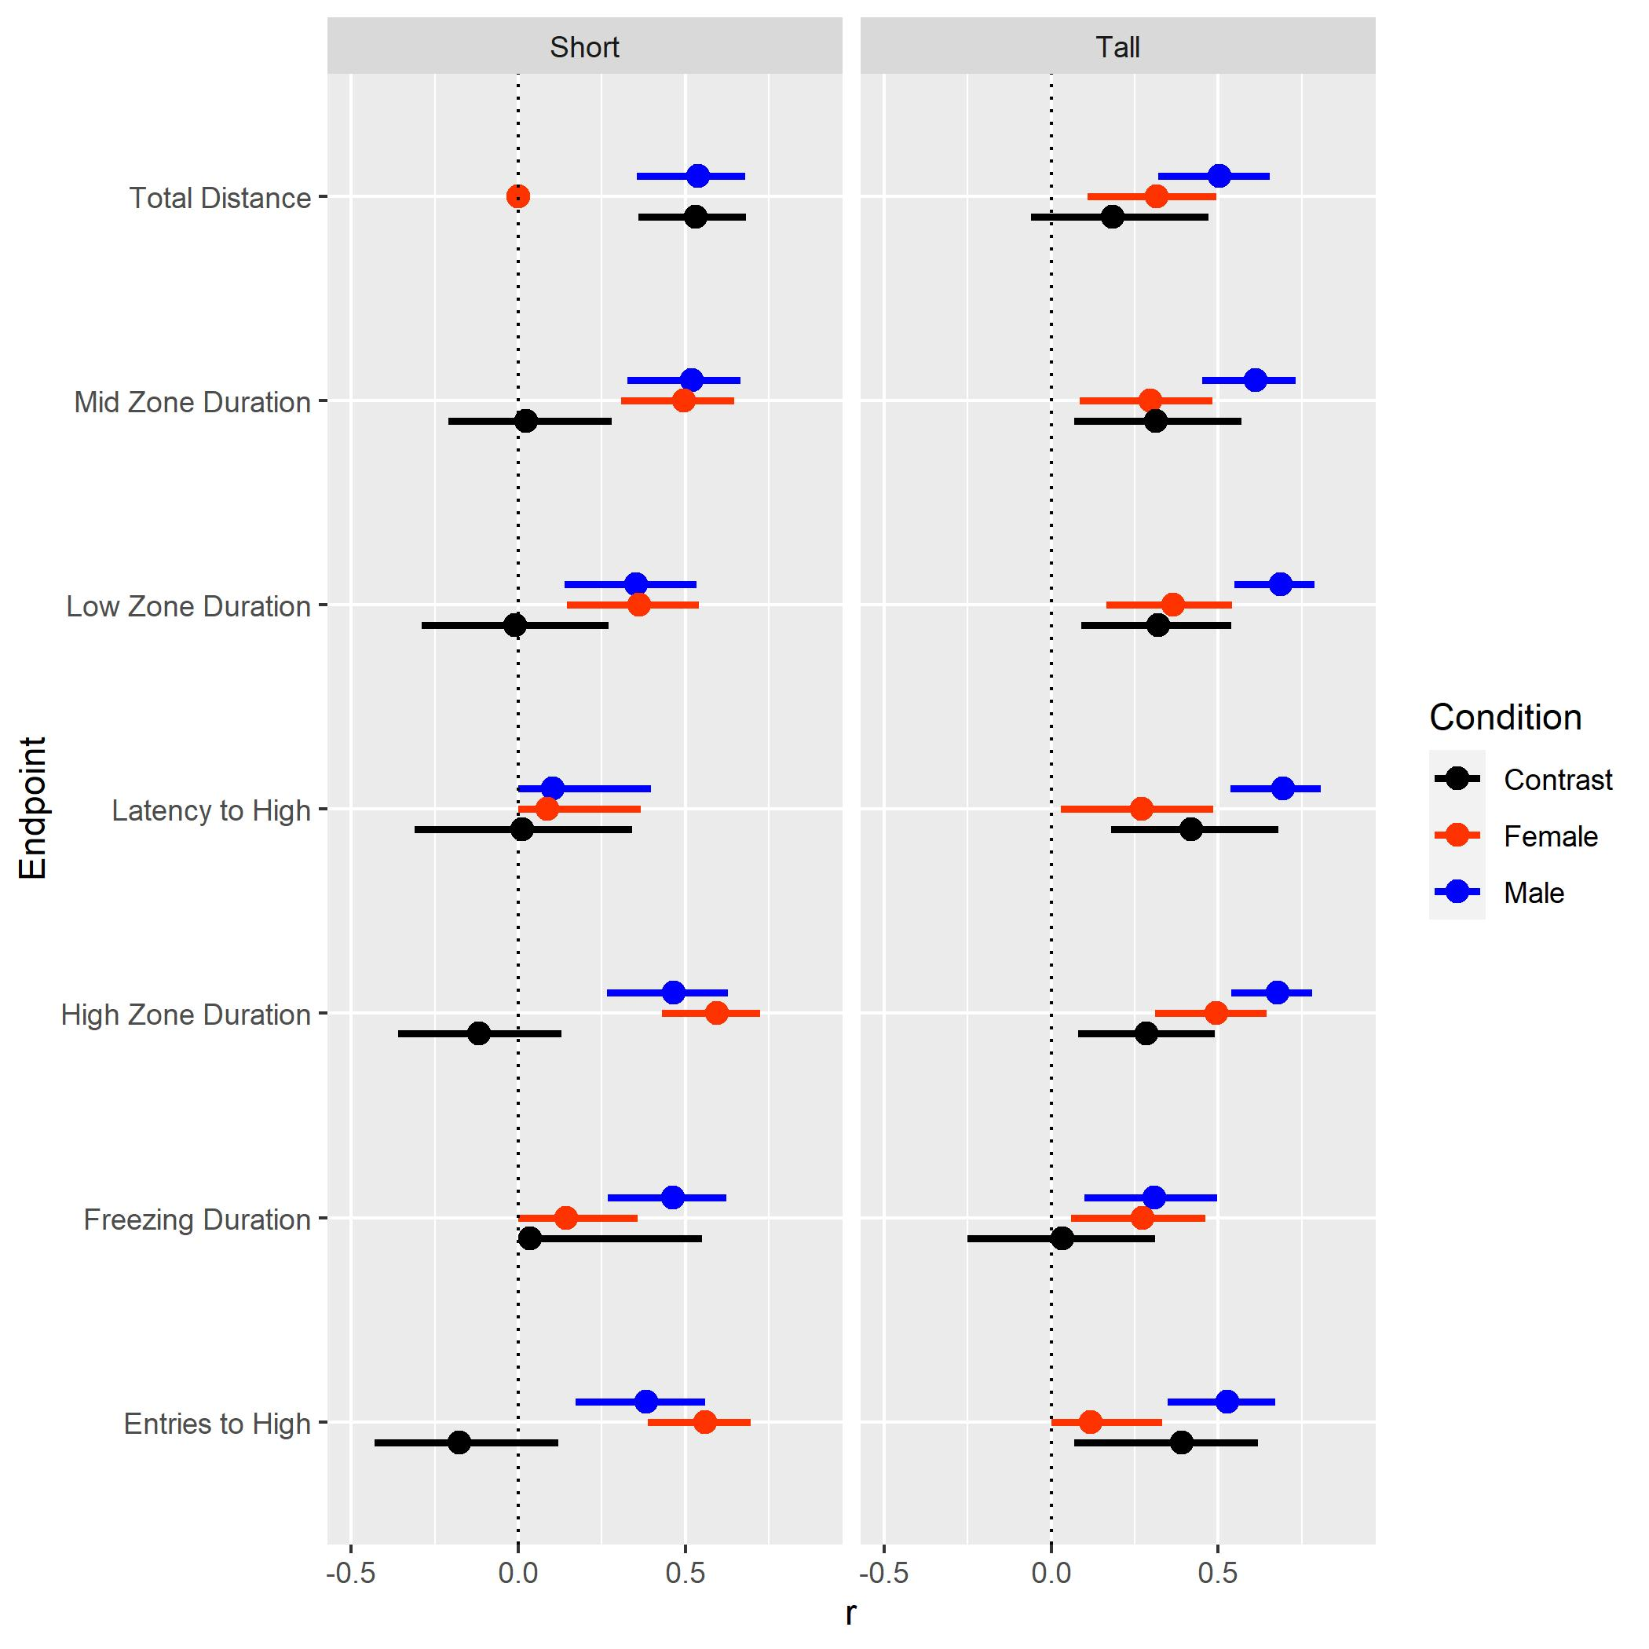

Figure 7)

**Supplementary Materials**

* Will add protocols for anxiety assay and Ethovision assay
* Need a table for the results of the systematic search
* Can add violin plots of other parameters
* TABLE 1) Results of systematic survey

Figure 1)

OTHER VIOLIN PLOTS FROM OTHER PARAMETERS THAT AREN’T VERY CLEAN CAN GO HERE ALSO